Overview
This demonstration will focus on how Virtuoso Universal Server can be used to transform unstructured and structured data into a knowledge graph, without compromise to scale or security.

Generating A Knowledge Graph from a WebPage (Unstructured + Structured Text)
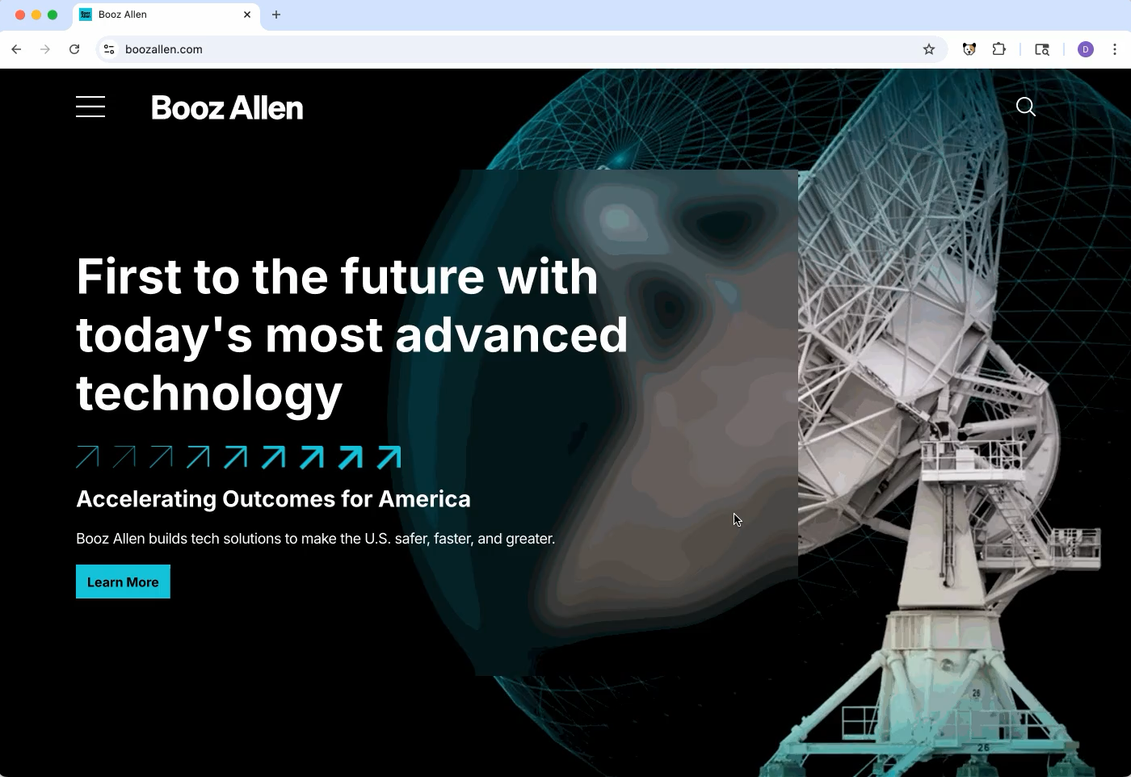
Using a combination of the OpenLink Structured Data Sniffer (OSDS) and Personal Assistant (OPAL), a knowledge graph can be immediately generated and stored without hand-written code.

Example: https://www.boozallen.com
- SPARQL SAMPLE() (Query Definition)
- Query Result

Generating a Knowledge Graphs from Unstructured Data via the OpenLink AI Layer (OPAL)

OPAL
(OPAL) is an LLM powered Smart Agent for invoking Actions via Functions that operate on data accessible via HTTP, ODBC, or JDBC.
OPAL is both MCP and A2A complient, and is immediately useable with OpenAI, Anthropic, Grok, Mistral, Gemini, and other LLM services. Additionally, it can be easily configured to use any LLM service that uses the OpenAI API URL pattern (E.G., OpenAI, Ollama, LM Studio, etc.)
Using The OpenLink AI Layer (OPAL), we can create and upload a knowledge graph using natural language.
The /chat interface interface allows users to communicate with Assistants powered by JSON configurations. These configurations can be used with OpenAI, Anthropic, Gemini, and other models.
The /assist-metal interface allows users to develop and communicate with assistants built for use with the OpenAI API

Generating a Knowledge Graph from Email Files
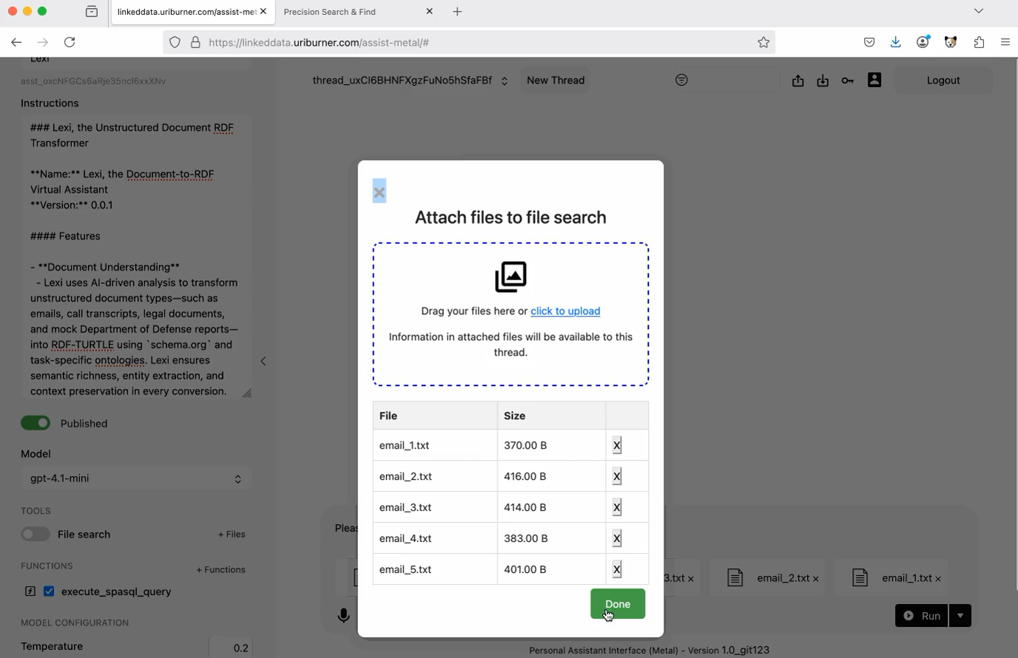
This example demonstrates adding email content and extracted entities to our knowledge graph.
- Conversation Link
- Example Query Definition
- Query Result
- Email Entity Description
- Faceted Search Result

Generating a Knowledge Graph from a Legal Document
This example demonstrates adding a Legal Document to our knowledge graph.
- Conversation Link
- Example Query Definition
- Example Query Result
- NDA Entity Description

Generating a Knowledge Graph using Call Transcripts
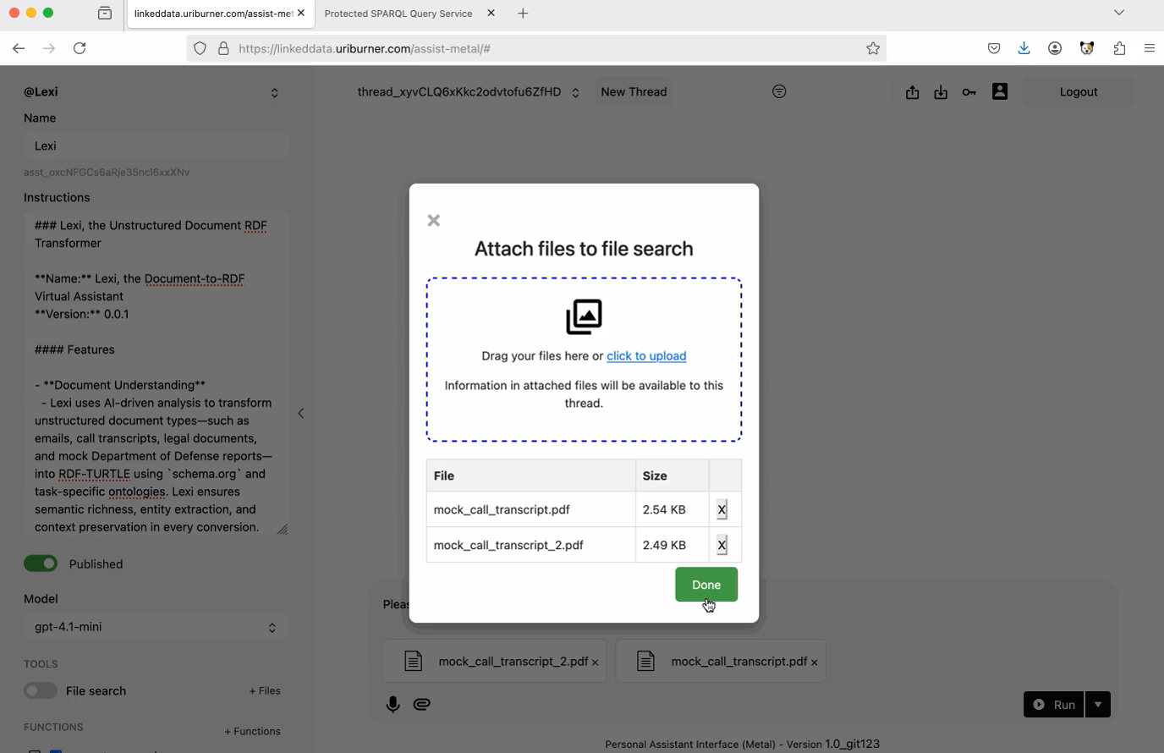
This example demonstrates converting call transcript files to RDF-TURTLE, and also executing entity extraction.
- Conversation Link
- Example Query Definition
- Example Query Result
- Example Call Log Entity Description

Generating a Knowledge Graph using a DoD Report

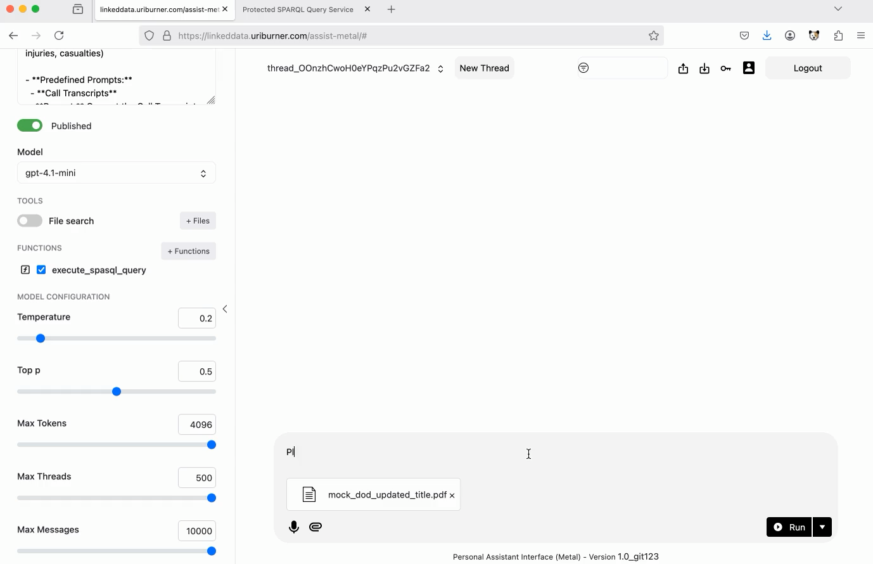
This example demonstrates converting a report to RDF-TURTLE, and adding it to our knowledge graph.
- Conversation Link
- Example Query Definition
- Example Query Result
- Description of Mock Exercise Iron Dagger 25

Integration with LLMs

OPAL
The OpenLink Personal Assistant (OPAL) is an LLM powered Smart Agent for invoking Actions via Functions that operate on data accessible via HTTP, ODBC, or JDBC.
OPAL is immediately useable with OpenAI, Anthropic, Grok, Mistral, and others. Additionally, can be easily configured to use any LLM service that uses the OpenAI API URL pattern (E.G., OpenAI, Ollama, LM Studio, etc.)
Webpage Integration
- Virtuoso Homepage
Evaluation License Generation
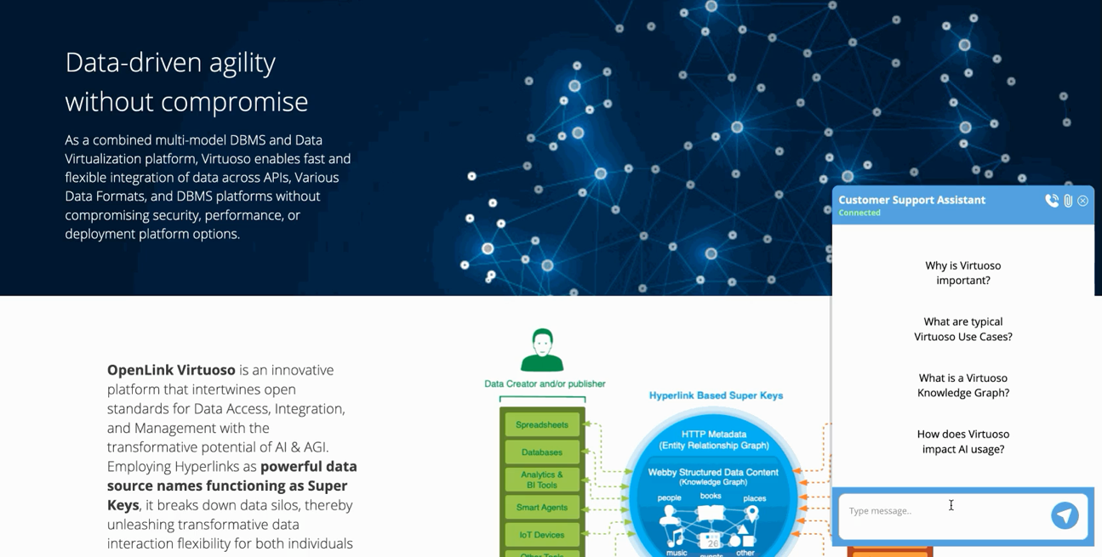

Support Agent
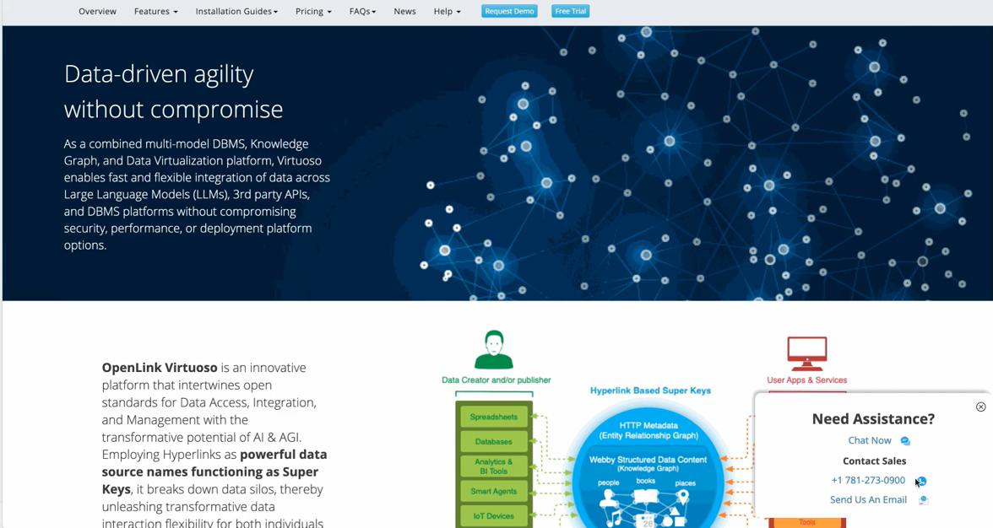

MCP Servers
Virtuoso and OPAL can also be utilized through use of MCP Servers.

Querying Attached PostgreSQL tables from Virtuoso via MCP and creating a Dashboard with Claude

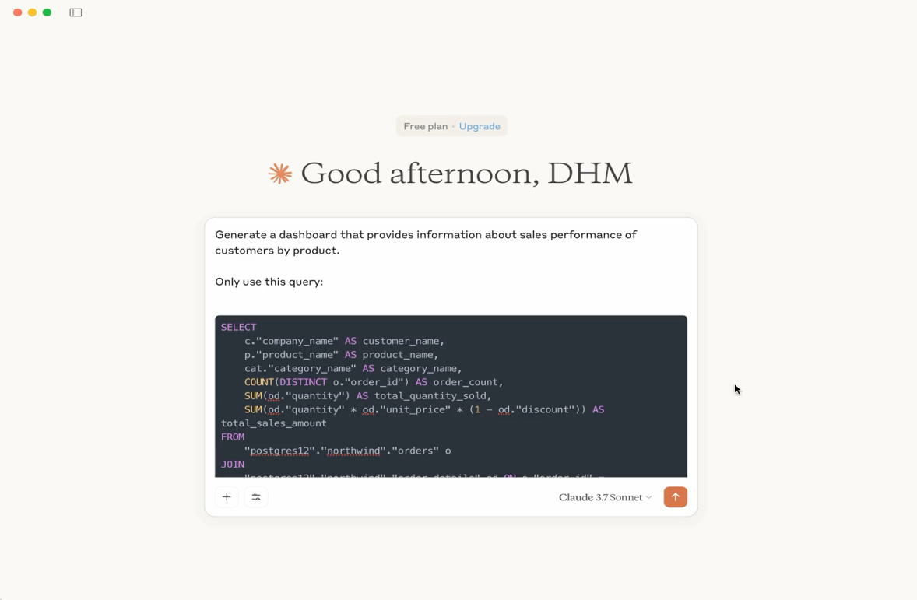

Using OPAL to query Virtuoso via MCP Inspector + SSE

OpenLink MCP Servers
- ODBC
  - ODBC
  - PyODBC
- JDBC
- ADO.NET
- SQLAlchemy

A2A Example

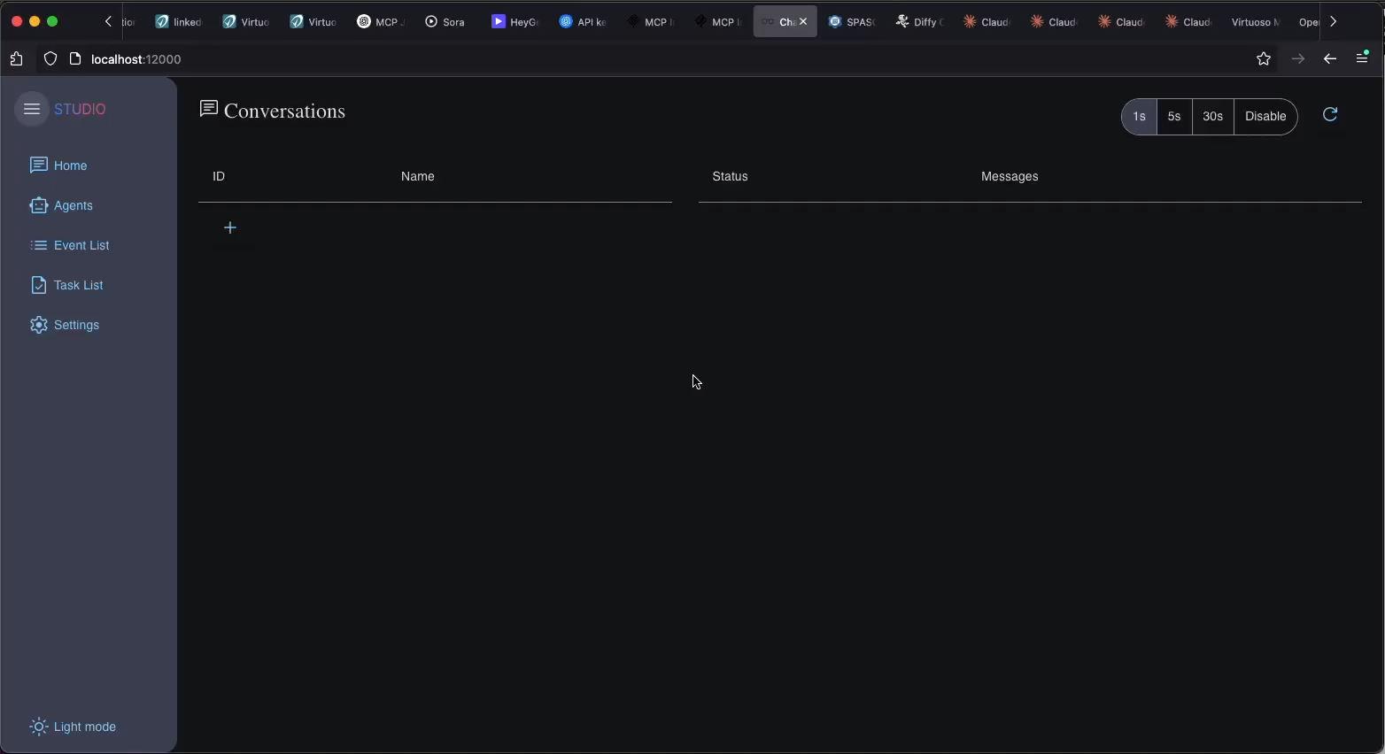
LangChain
- LangChain example

Additional Examples

Virtual + Physical Knowledge Graphs from CSV Documents

Dataset
This synthetic dataset includes:
- Transaction Data: Details of financial transactions including transaction ID, timestamp, amount, sender and receiver account numbers, transaction type, and status.
- Customer Data: Customer profiles including customer ID, name, address, account numbers, transaction history, and risk scores.
- Account Data: Information about different accounts, balances, account types, and linked customers.
- Fraud Labels: Indicate whether a transaction is fraudulent or not (for training and validation in machine learning models).
- Github Repository

Script Breakdown: Creating a Knowledge Graph from 80 CSV Documents.
Convert customer and transaction data into Virtual and Physical RDF triples using R2RML (Wizard and Linked Data View Generator).
Load Data into Virtual and Physical SQL Tables
Install Custom Stored Procedure for quickly mapping multiple CSV documents to a virtual SQL Table:
-- Install ATTACH_FROM_CSV_DIR
DROP PROCEDURE file_dirlist_full;
CREATE PROCEDURE file_dirlist_full (IN a ANY)
{
DECLARE _inx integer;
DECLARE F VARCHAR;
DECLARE L INT;

F := file_dirlist(a,1);
L := length(F);
_inx := 0;

While(_inx < L){
DECLARE v any;
F[_inx] := concat(a,'/',F[_inx]);
_inx := _inx + 1;

}

return F;

};

DROP PROCEDURE attach_from_csv_dir;
CREATE PROCEDURE attach_from_csv_dir (IN tb VARCHAR, IN dir ANY, in delimiter VARCHAR, in newline VARCHAR, in esc VARCHAR, in skip_rows int, in pkey_columns any := null)
{
declare f VARCHAR;

f:= attach_from_csv(tb,file_dirlist_full(dir),delimiter,newline,esc,skip_rows,pkey_columns);

return F;
};

Create Virtual and Physical SQL Tables of CSV Data
SPARQL CLEAR GRAPH <urn:demo.openlinksw.com:fint>;

DROP TABLE demo.fint.account IF EXISTS;
DROP TABLE demo.fint.customer IF EXISTS;
DROP TABLE demo.fint.transaction IF EXISTS;
DROP TABLE demo.fint.fraud_label IF EXISTS;

DROP TABLE demo.fint.account_physical IF EXISTS;
DROP TABLE demo.fint.customer_physical IF EXISTS;
DROP TABLE demo.fint.transaction_physical IF EXISTS;
DROP TABLE demo.fint.fraud_label_physical IF EXISTS;

ATTACH_FROM_CSV_DIR('demo.fint.account','fint/synthetic_data/accounts',',','\n',null,1,VECTOR(1));
ATTACH_FROM_CSV_DIR('demo.fint.customer','fint/synthetic_data/customers',',','\n',null,1,VECTOR(1));
ATTACH_FROM_CSV_DIR('demo.fint.transaction','fint/synthetic_data/transactions',',','\n',null,1,VECTOR(1));
ATTACH_FROM_CSV_DIR('demo.fint.fraud_label','fint/synthetic_data/fraud_labels',',','\n',null,1,VECTOR(1));

GRANT SELECT ON demo.fint.account to SPARQL_SELECT;
GRANT SELECT ON demo.fint.customer to SPARQL_SELECT;
GRANT SELECT ON demo.fint.transaction to SPARQL_SELECT;
GRANT SELECT ON demo.fint.fraud_label to SPARQL_SELECT;

-- Optional Create SQL Tables Containing Physical Data

CREATE TABLE demo.fint.account_physical
AS SELECT * FROM demo.fint.account
WITH DATA;

CREATE TABLE demo.fint.customer_physical
AS SELECT * FROM demo.fint.customer
WITH DATA;

CREATE TABLE demo.fint.transaction_physical
AS SELECT * FROM demo.fint.transaction
WITH DATA;

CREATE TABLE demo.fint.fraud_label_physical
AS SELECT * FROM demo.fint.fraud_label
WITH DATA;

GRANT SELECT ON demo.fint.account_physical to SPARQL_SELECT;
GRANT SELECT ON demo.fint.customer_physical to SPARQL_SELECT;
GRANT SELECT ON demo.fint.transaction_physical to SPARQL_SELECT;
GRANT SELECT ON demo.fint.fraud_label_physical to SPARQL_SELECT;

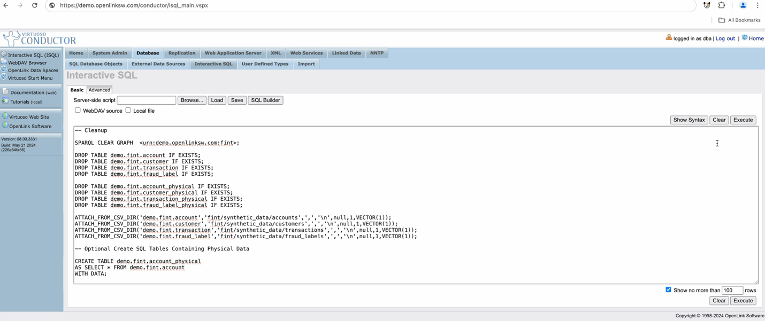

Confirm Virtual and Physical Table Creation by Chatting with our Data:
We can use OPAL to query the generated table using natural language. A configuration file provides the DDL (Data Definition Language), which can be used to generate queries, provide hard-coded queries to execute, and deliver answers.
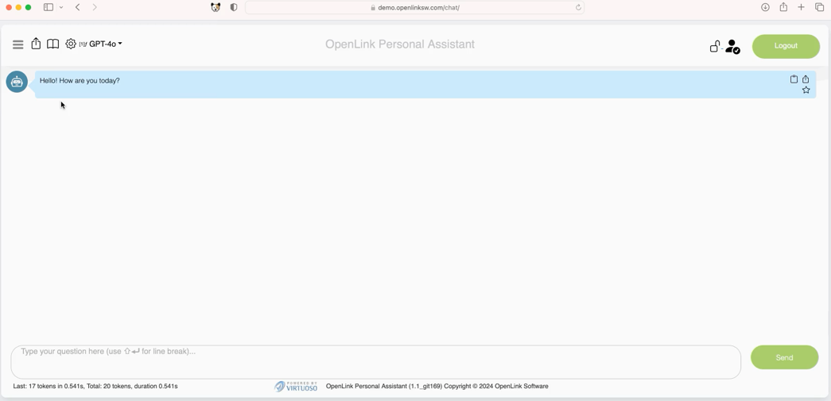
- Conversation Link

Generate Virtual and Physical Linked Data Views

Option 1: R2RML Wizard (for users who already have an R2RML Script)
- Test Query Definition
- Test Query Result against Virtual Linked Data View

Option 2: Linked Data View Generator (for users who want an automatically generated mapping and ontology)

Option 3: SQL Script
- Example

Chatting with our Knowledge Graph to confirm its creation
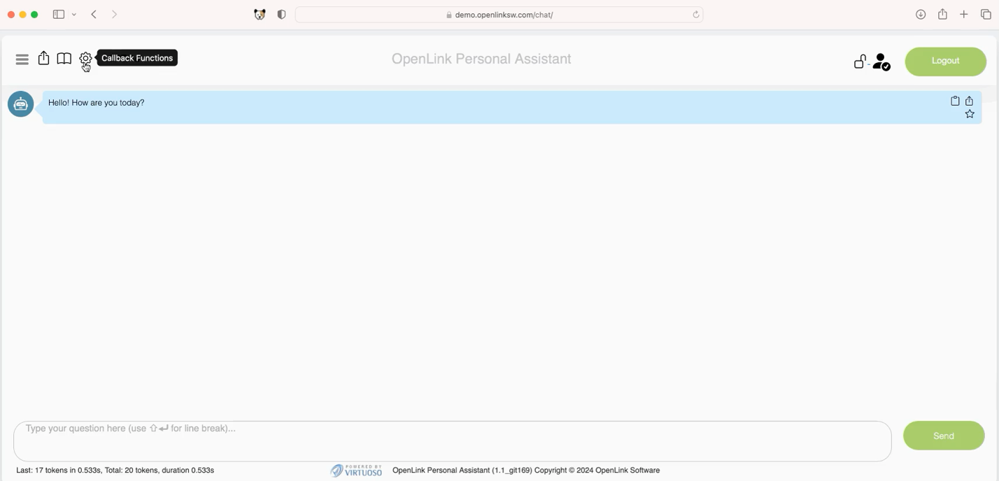
- Conversation Link

Querying Virtuoso

SPARQL Query Editor
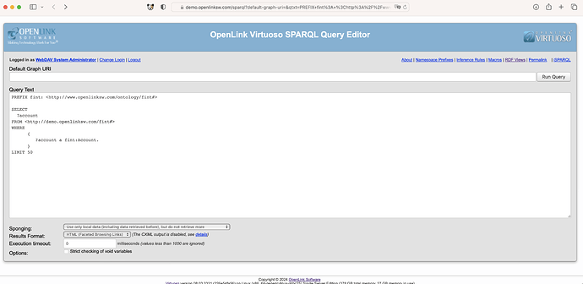

- Query Definition
- Query Result

Authentication Demo
When logged in as demo, we can access the Virtual Named Graph after authenticating due to SELECT permissions having been granted in the setup script. Without having granted SELECT permissions on the underlying table, access will be denied:
SPARQL Query Editor Example
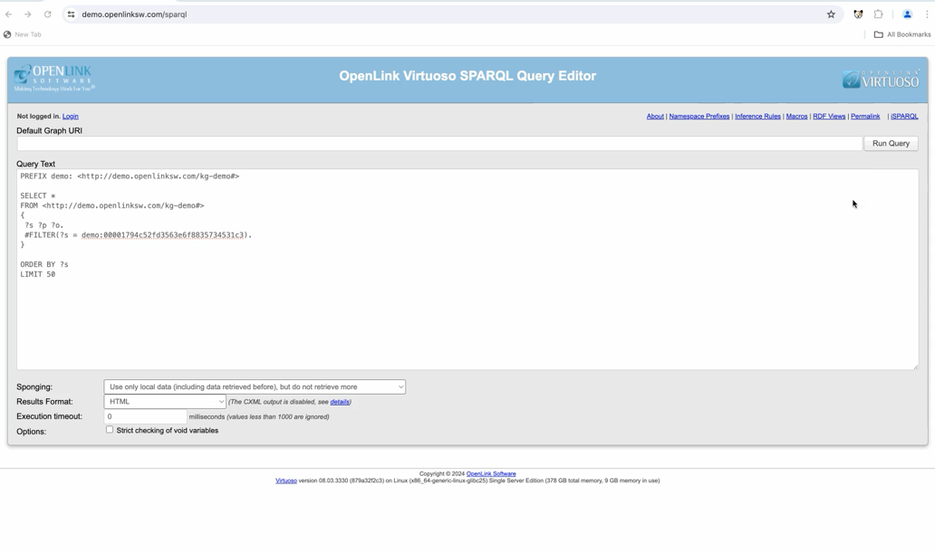
cURL Example
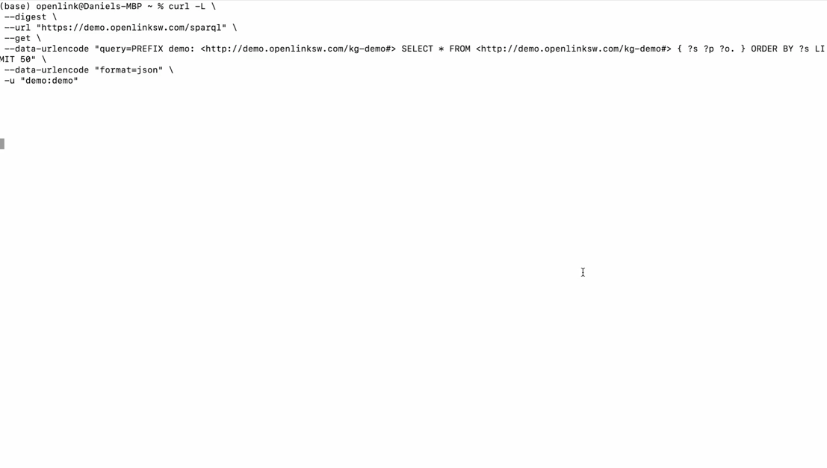
This is a result of ACLs applied to the Virtuoso Authentication Layer (VAL). VAL is an open-standards-based, multi-protocol authentication layer, that provides fine-grained, attributed-based access controls (ABAC) for protected resources (HTTP-accessible documents, folders, services [via their endpoints], and SPARQL named graphs). In a nutshell, this solution uses logic, expressed in the form of entity relationships, to address issues such as identity, authorization, and restriction.
ACLs can be applied to physical and virtual data, in addition to limiting access and usage to applications and services.

SPASQL QB

SPARQL-within-SQL Example
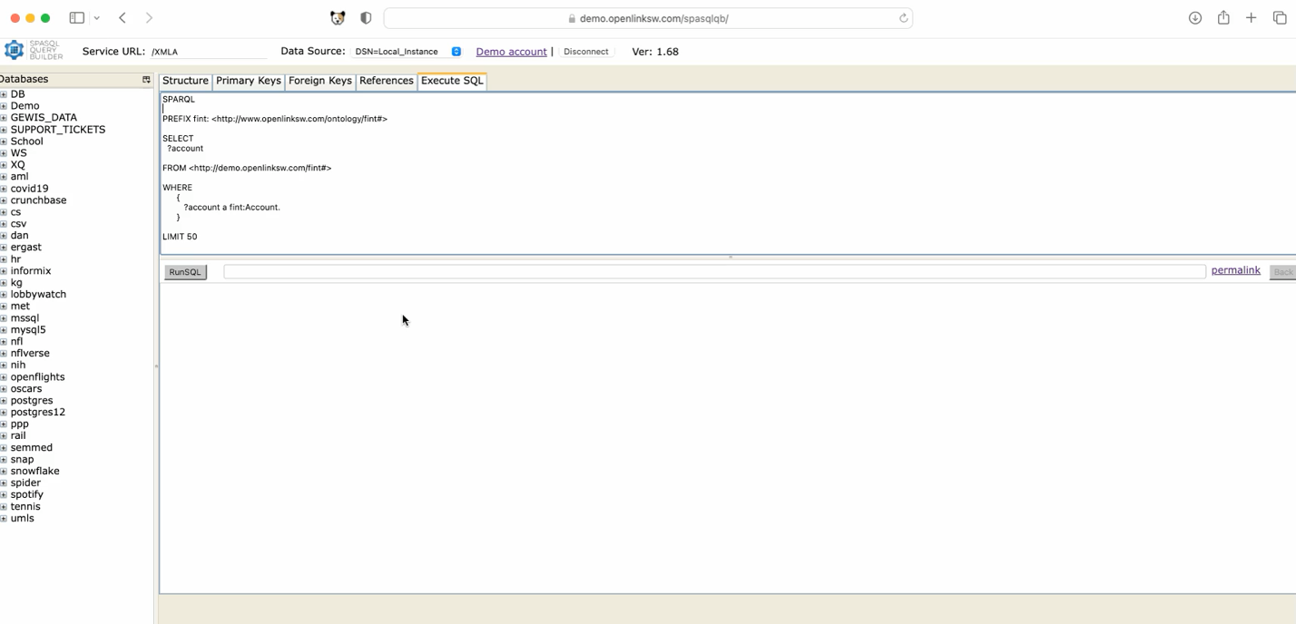
- Blue Links = Globally Resolvable

SQL Example
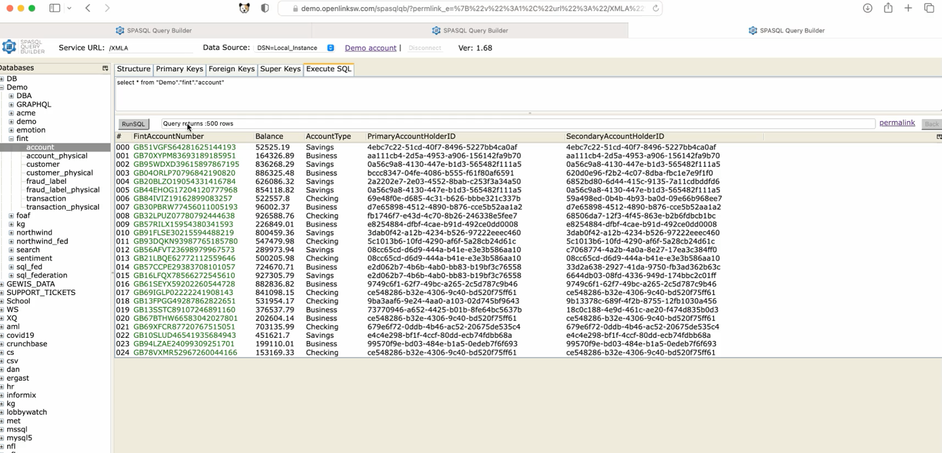
- Green Links = Locally Resolvable
- Query Result using SPASQLQB

Example Queries Against the Physical Dataset:
- List All Accounts and their Primary + Secondary Account Holders
  - Query Definition
  - Query Result
- List All Accounts and their Balances
  - Query Definition via SPARQL Query Editor

List All Accounts With a Primary or Secondary Account Holder with a Risk Score over 80.
- Query Definition
- Query Result

Using Third-Party Tools
Any ODBC-, JDBC-, or HTTP-compliant application can connect to Virtuoso.

NetworkX (HTTP, ODBC, JDBC)
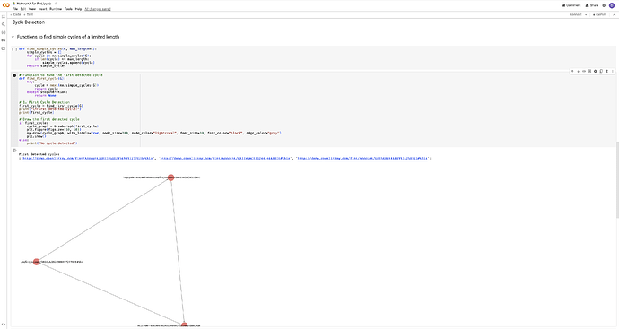
Screenshot 2024-06-13 at 12.45.20 AM3454×1840 386 KB

- Google Colab Notebook

Excel

Tableau (ODBC or JDBC)
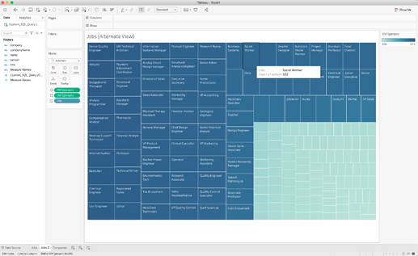

Neo4j (JDBC)
Example HTTP(s) consumer utilizing GraphQL
In this example, we demonstrate the use of GraphQL with an HTML-based Single Page Application (SPA) operating on data retrieved from Virtuoso using SPARQL.
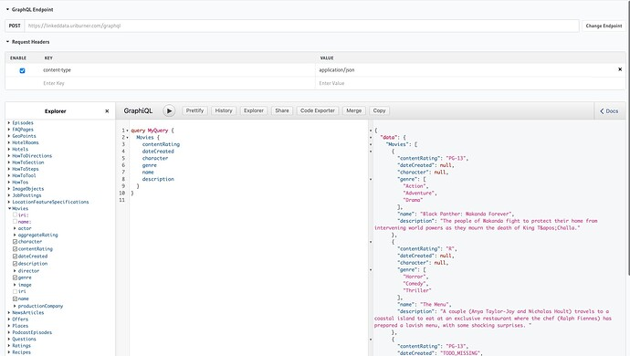

- Live Example

Federated Queries

Creating a Knowledge Graph from Federated SQL RDBMS Tables (local, SQLServer, MySQL)
- Tables can be attached via Conductor interface, or programmatically using the ATTACH_TABLE() command.
- Federated SQL Query Example
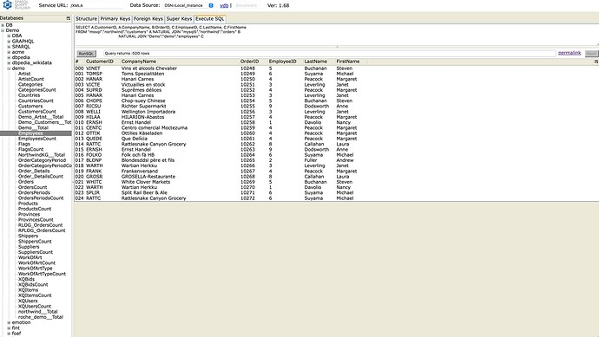
Virtual and Physical RDF Views can be generated using the “Linked Data Views” feature, or using an R2RML script.

Storing the query as a SQL View
DROP TABLE demo.sql_federation.data;
CREATE VIEW demo.sql_federation.data AS
(
SELECT
A.CustomerID,
A.CompanyName,
B.OrderID,
C.EmployeeID,
C.LastName,
C.FirstName
FROM
"sqlserver"."northwind"."customers" A
NATURAL JOIN
"mysql5"."northwind"."orders" B
NATURAL JOIN
"Demo"."demo"."employees" C
);

GRANT SELECT ON demo.sql_federation.data TO SPARQL_SELECT;

Creating a Virtual Linked Data View
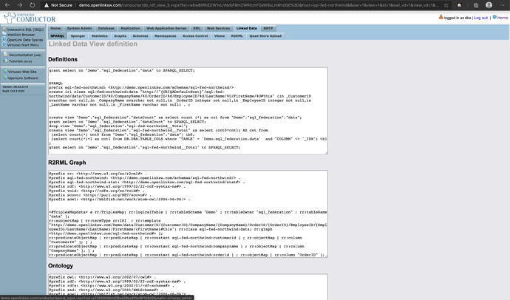

- Example Query Definition
- Example Query Result

Federated SPARQL Queries (SPARQL-FED)
List the Awards, past partners, and past/current spouses of Robert Downey Jr.
- Query Definition: Raw
- Query Result: Raw
- Query Definition: Minimized with group_concat()
- Query Result: Minimized with group_concat()

Attribute-based Access Control (ABAC) Example
In this example, access control is used to constrain access to a specific named graph such that, when users haven’t logged in via successful authentication, query solutions scoped to the graph return nothing. In other words, only authenticated users will receive query solutions from the protected named graph.
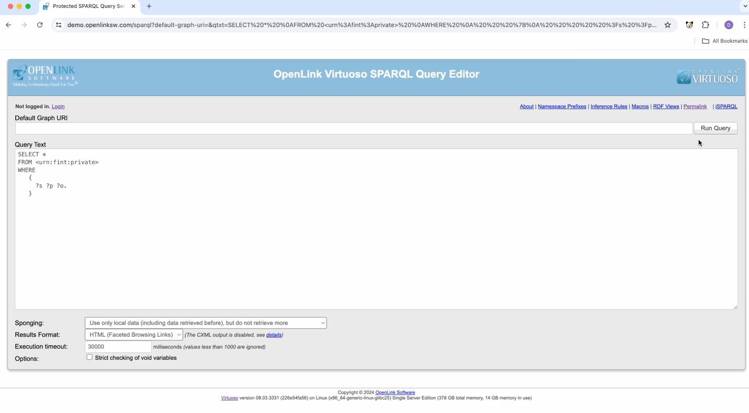

Script used to implement ACL above
-- Cleanup

SPARQL CLEAR GRAPH <urn:fint:private>;

SPARQL
DELETE WHERE
{
GRAPH <http://demo.openlinksw.com/acl/graph/rules/http%3A%2F%2Fwww.openlinksw.com%2Fontology%2Facl%23DefaultRealm>
{
<urn:fint:private:rule> ?p ?o
}
} ;

-- Make Named Graph Private

DB.DBA.RDF_GRAPH_GROUP_INS ('http://www.openlinksw.com/schemas/virtrdf#PrivateGraphs', 'urn:fint:private');

-- Add an ACL

SPARQL
PREFIX oplacl: <http://www.openlinksw.com/ontology/acl#>
PREFIX acl: <http://www.w3.org/ns/auth/acl#>
INSERT INTO GRAPH <http://demo.openlinksw.com/acl/graph/rules/http%3A%2F%2Fwww.openlinksw.com%2Fontology%2Facl%23DefaultRealm>
{
<urn:fint:private:rule> a acl:Authorization ;
foaf:maker <#dhm> ;
oplacl:hasAccessMode oplacl:Read ;
acl:accessTo <urn:fint:private> ;
acl:agent <http://demo.openlinksw.com/dataspace/person/demo#this>;
oplacl:hasScope oplacl:PrivateGraphs ;
oplacl:hasRealm oplacl:DefaultRealm .
};

- Query Definition – Login using demo:demo to see the protected content when executing the query
- ACL Quickstart Guide

Benchmarks
- Berlin SPARQL Benchmark (BSBM) Results
- LOD2 BSBM150 Billion Triple
- LOD2 BSBM 500 Billion Triple
- LDBC SNB & SPB Benchmarks
- Hobbit Data Storage Benchmark
- SAGE GeoSPARQL Compliance Benchmark
- LUBM

Loading
- LD Meter – RDF Load Rate Monitor tool
- Loading the Wikidata 2024/04 dataset into Virtuoso Open Source — RDF Load Rate Monitor tool

Reasoning and Inference

Built-In Reasoning and Inference (RDFS, OWL)
- Using British Royal Family Data Snippets — to demonstrate SPARQL Query Language-based Reasoning & Inference | by Kingsley Uyi Idehen | OpenLink Virtuoso Weblog | Medium

Custom Reasoning and Inference (SPIN):
- Magic Sets and Custom Inference Rules in Virtuoso 8.x | by Kingsley Uyi Idehen | OpenLink Virtuoso Weblog | Medium

Public Instance Analysis
- Public Virtuoso Instance Analysis -- INI Files and DB Metadata - Google Spreadsheets

