Overview
This guide covers the use of Virtuoso for creating and using physical or virtual knowledge graphs generated from a variety of sources, without compromising scalability or security.
Often, this guide will include an animated GIF and links to live demonstrations to aid understanding of these matters.

Physical Knowledge Graph

Generating A Knowledge Graph from a Webpage

Using a combination of the OpenLink Structure Data Sniffer (OSDS) and Personal Assistant (OPAL), a knowledge graph can be immediately generated and stored without hand-written code.

Example: https://morganstanley.com

- SPARQL SAMPLE() (Query Definition)
- Query Result
- Morgan Stanley Homepage Description

Virtual and Physical Knowledge Graphs

Dataset
This synthetic dataset includes:
- Transaction Data: Details of financial transactions including transaction ID, timestamp, amount, sender and receiver account numbers, transaction type, and status.
- Customer Data: Customer profiles including customer ID, name, address, account numbers, transaction history, and risk scores.
- Account Data: Information about different accounts, balances, account types, and linked customers.
- Fraud Labels: Indicate whether a transaction is fraudulent or not (for training and validation in machine learning models).
- Github Repository

Creating a Knowledge Graph from 80 CSV Documents.
Convert customer and transaction data into Virtual and Physical RDF triples using R2RML (Wizard and Linked Data View Generator).

Load Data into Virtual and Physical SQL Tables
Install Custom Stored Procedure for quickly mapping multiple CSV documents to a virtual SQL Table:
-- Install ATTACH_FROM_CSV_DIR
DROP PROCEDURE file_dirlist_full;
CREATE PROCEDURE file_dirlist_full (IN a ANY)
{
DECLARE _inx integer;
DECLARE F VARCHAR;
DECLARE L INT;

F := file_dirlist(a,1);
L := length(F);
_inx := 0;

While(_inx < L){
DECLARE v any;
F[_inx] := concat(a,'/',F[_inx]);
_inx := _inx + 1;

}
return F;
};

DROP PROCEDURE attach_from_csv_dir;
CREATE PROCEDURE attach_from_csv_dir (IN tb VARCHAR, IN dir ANY, in delimiter VARCHAR, in newline VARCHAR, in esc VARCHAR, in skip_rows int, in pkey_columns any := null)
{
declare f VARCHAR;

f:= attach_from_csv(tb,file_dirlist_full(dir),delimiter,newline,esc,skip_rows,pkey_columns);

return F;
};

Create Virtual and Physical SQL Tables of CSV Data

-- Cleanup
SPARQL CLEAR GRAPH <urn:demo.openlinksw.com:fint>;

DROP TABLE demo.fint.account IF EXISTS;
DROP TABLE demo.fint.customer IF EXISTS;
DROP TABLE demo.fint.transaction IF EXISTS;
DROP TABLE demo.fint.fraud_label IF EXISTS;

DROP TABLE demo.fint.account_physical IF EXISTS;
DROP TABLE demo.fint.customer_physical IF EXISTS;
DROP TABLE demo.fint.transaction_physical IF EXISTS;
DROP TABLE demo.fint.fraud_label_physical IF EXISTS;

ATTACH_FROM_CSV_DIR('demo.fint.account','fint/synthetic_data/accounts',',','\n',null,1,VECTOR(1));
ATTACH_FROM_CSV_DIR('demo.fint.customer','fint/synthetic_data/customers',',','\n',null,1,VECTOR(1));
ATTACH_FROM_CSV_DIR('demo.fint.transaction','fint/synthetic_data/transactions',',','\n',null,1,VECTOR(1));
ATTACH_FROM_CSV_DIR('demo.fint.fraud_label','fint/synthetic_data/fraud_labels',',','\n',null,1,VECTOR(1));

-- Map CSVs to Virtual Tables
GRANT SELECT ON demo.fint.account to SPARQL_SELECT;
GRANT SELECT ON demo.fint.customer to SPARQL_SELECT;
GRANT SELECT ON demo.fint.transaction to SPARQL_SELECT;
GRANT SELECT ON demo.fint.fraud_label to SPARQL_SELECT;

-- Optional Create SQL Tables Containing Physical Data
CREATE TABLE demo.fint.account_physical
AS SELECT * FROM demo.fint.account
WITH DATA;

CREATE TABLE demo.fint.customer_physical
AS SELECT * FROM demo.fint.customer
WITH DATA;

CREATE TABLE demo.fint.transaction_physical
AS SELECT * FROM demo.fint.transaction
WITH DATA;

CREATE TABLE demo.fint.fraud_label_physical
AS SELECT * FROM demo.fint.fraud_label
WITH DATA;

GRANT SELECT ON demo.fint.account_physical to SPARQL_SELECT;
GRANT SELECT ON demo.fint.customer_physical to SPARQL_SELECT;
GRANT SELECT ON demo.fint.transaction_physical to SPARQL_SELECT;
GRANT SELECT ON demo.fint.fraud_label_physical to SPARQL_SELECT;

We can use OPAL to query the generated table using natural language. A configuration file provides the DDL (Data Definition Language), which can be used to generate queries, provide hard-coded queries to execute, and deliver answers.

- Live Conversation Link

Generate Virtual and Physical Linked Data Views

Option 1: R2RML Wizard (for users who already have an R2RML Script)
- Test Query Definition
- Test Query Result against Virtual Linked Data View

Option 2: Linked Data View Generator (for users who want an automatically generated mapping and ontology)

Option 3: SQL Script
- Example

Chatting with our Knowledge Graph to confirm its creation.

- Live Conversation Link

Querying Virtuoso

SPARQL Query Editor
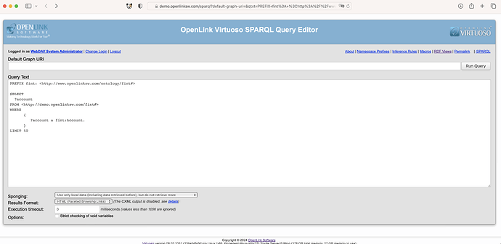
- Query Definition
- Query Result

Data Governance & Security
When logged in as user “demo”, courtesy of SELECT permissions privileges granted in the setup script, SPARQL access to the Virtual Graph created earlier is possible. Without these SELECT privileges, attempts to access other Virtual is denied.

SPARQL Query Editor Authentication Example

cURL Authentication Example

This is a result of ACLs applied to the Virtuoso Authentication Layer (VAL). VAL is an open-standards-based, multi-protocol authentication layer, that provides fine-grained, attributed-based access controls (ABAC) for protected resources (HTTP-accessible documents, folders, services [via their endpoints], and SPARQL named graphs). In a nutshell, this solution uses logic, expressed in the form of entity relationships, to address issues such as identity, authorization, and restriction.
ACLs can be applied to physical and virtual data, in addition to limiting access and usage to applications and services.

SPARQL and SQL Query Builder (a/k/a SPASQL QB for short)

SPASQL QB Example – demonstrating SPARQL usage from SQL.

Note:
- Green Link resolve locally i.e., expanding to an expansive query across all related tables.
- Blue Links (hyperlinks) resolve globally to entity descriptions i.e., via any application (e.g., browser) that supports HTTP.

SQL Example

- Green Links = Locally Resolvable
- Query Result using SPASQLQB

Example SPARQL Queries Against the Physical Graph
- List All Accounts and their Primary + Secondary Account Holders
  - Query Definition
  - Query Result
- List All Accounts and their Balances
  - Query Definition via SPARQL Query Editor

List All Accounts With a Primary or Secondary Account Holder with a Risk Score over 80.
- Query Definition
- Query Result

Anti Money Laundering (AML) Find Cyclical Transactions
- Query Definition
- Query Result

Virtuoso’s Anytime Query Feature

Virtuoso’s Anytime Query feature is a unique DBMS engine innovation that enables it provide a query solution with a set timeframe, irrespective of the following:
- Query Complexity
- Query Solution Size
- Number of concurrent users issuing queries

This feature is instrumental to his predominance with the massive Linked Open Data (LOD) Cloud collection of publicly accessible SPARQL-compliant Knowledge Graphs e.g., DBpedia, Uniprot, and many others (e.g. hosting from 10 billion to 147 billion RDF triples). Each of these 24/7 instances is exposed to unpredictable query loads originating from a variety of sources across the World Wide Web.

- Query Definition with a 1000ms timeout
- Query Definition with a 2500ms timeout

Using Third-Party Tools
Any ODBC-, JDBC-, or HTTP-compliant application can interact with Virtuoso using SQL or SPARQL (courtesy of SPASQL).

NetworkX (HTTP, ODBC, JDBC)

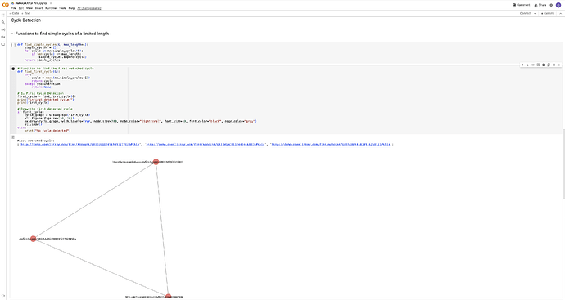
- Google Colab Notebook

Microsoft Excel (via ODBC)

Tableau (via ODBC or JDBC)

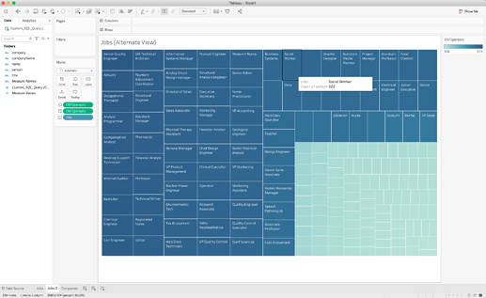

Neo4j (via JDBC)

GraphQL Access (usable by an HTTP-application)

In this example, we demonstrate the use of GraphQL with an HTML-based Single Page Application (SPA) operating on data retrieved from Virtuoso using SPARQL.
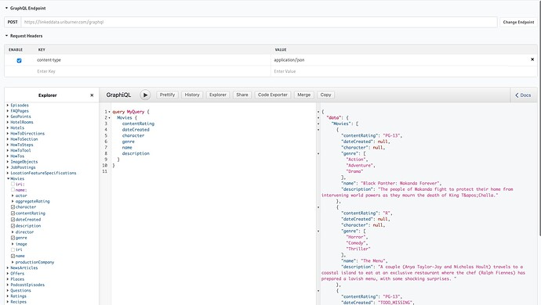

- Live Example

Federated Queries
Creating a Knowledge Graph from Federated SQL RDBMS Tables (local, SQLServer, MySQL). Tables can be attached via Conductor interface or ATTACH_TABLE() SQL command.

Federated SQL Query Example
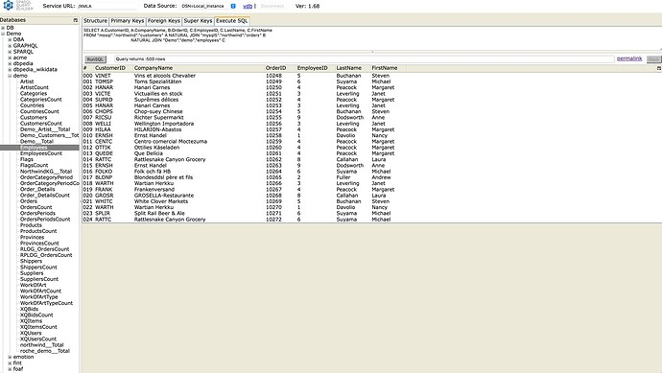

Virtual and Physical RDF Views can be generated using the “Linked Data Views” feature or using an R2RML script.

Storing the Query as a SQL View

DROP TABLE demo.sql_federation.data;
CREATE VIEW demo.sql_federation.data AS
(
SELECT
A.CustomerID,
A.CompanyName,
B.OrderID,
C.EmployeeID,
C.LastName,
C.FirstName
FROM "mssql"."northwind"."customers" A
NATURAL JOIN "mysql5"."northwind"."orders" B
NATURAL JOIN "Demo"."demo"."employees" C
);

GRANT SELECT ON demo.sql_federation.data TO SPARQL_SELECT;

Creating a Virtual Linked Data View

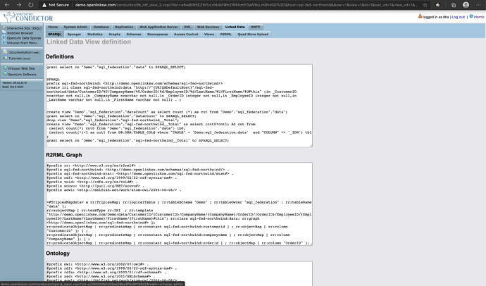

- Example Query Definition
- Example Query Result

Federated SPARQL Queries (SPARQL-FED)
List the Awards, past partners, and past/current spouses of Robert Downey Jr.
- Query Definition: Raw
- Query Result: Raw
- Query Definition: Minimized with group_concat()
- Query Result: Minimized with group_concat()

Large Language Model (LLM) Integration

OpenLink Personal Assistant (OPAL)

OPAL is a guard-railed interface to ChatGPT that uses external function integration to extend its underlying GPT family of languages. Functionality enhancements can be provided via Virtuoso-hosted stored procedures or 3rd party OpenAPI-compliant web services. For example, as depicted below, this can take the form of adding direct execution SQL, SPARQL, SPASQL, or GraphQL queries that lookup designated Knowledge Graphs as part of a Retrieval Augmented Generation (RAG) pipeline aimed at minimizing the effects of LLM-hallucinations.

Use Case Examples

Providing a conversation interface to customers, partners, and prospects that enables them find information across websites with precision and then acting on it immediately.
- Virtuoso Website
- OpenLink ODBC and JDBC Drivers Website
- OpenLink Website

Evaluation License Generation Example

Support Assistance

Other Large Language Model (LLM) oriented Frameworks Support

Virtuoso is also usable via Retrieval Augmented Generation (RAG) oriented frameworks such as LangChain and LlamaIndex. In the case of LangChain, SQLAlchemy (an Object-Relational Abstraction Layer) atop PyODBC provide data access interfaces. The link below denotes a page comprising a detailed example of solutions built atop Virtuoso using either framework.
- LangChain Example
- LLamaIndex Example

Knowledge Graph Governance via Access Controls

Virtuoso includes a powerful and scalable solution for knowledge graph governance in the form of Attribute-Based Access Controls (ABAC). This approach to data governance is based on a semantic graph comprising entity relationships that collectively enable the construction of data access policies, in RDF, that describe who has access to what graphs (virtual or physical) and under what conditions.
An ABAC ACL comprises the following:
- Identity Principals – individuals, groups, or conditional groups (which can even be constructed using SPARQL ASK queries).
- Authorizations – which determine privileges granted to identity principals on designated knowledge graphs.
- Realms (e.g., SQL, SPARQL etc) to which authorizations apply.
- Scopes to which authorizations apply (e.g., PrivateGraphs, other Graph Groups).
- Restrictions – that further constrain authorizations.
Here’s a script used to implement an example ACL.

-- Cleanup
SPARQL CLEAR GRAPH <urn:fint:private>;

SPARQL
DELETE WHERE
{
GRAPH <http://demo.openlinksw.com/acl/graph/rules/http%3A%2F%2Fwww.openlinksw.com%2Fontology%2Facl%23DefaultRealm>
{
<urn:fint:private:rule> ?p ?o
}
} ;

-- Make Named Graph Private

DB.DBA.RDF_GRAPH_GROUP_INS ('http://www.openlinksw.com/schemas/virtrdf#PrivateGraphs', 'urn:fint:private');

-- Add an ACL
SPARQL
PREFIX oplacl: <http://www.openlinksw.com/ontology/acl#>
PREFIX acl: <http://www.w3.org/ns/auth/acl#>
INSERT INTO GRAPH <http://demo.openlinksw.com/acl/graph/rules/http%3A%2F%2Fwww.openlinksw.com%2Fontology%2Facl%23DefaultRealm>
{
<urn:fint:private:rule> a acl:Authorization ;
foaf:maker <#dhm> ;
oplacl:hasAccessMode oplacl:Read ;
acl:accessTo <urn:fint:private> ;
acl:agent <http://demo.openlinksw.com/dataspace/person/demo#this>;
oplacl:hasScope oplacl:PrivateGraphs ;
oplacl:hasRealm oplacl:DefaultRealm .
};

Illustrated below is a demonstration of the effects of the ABAC ACL on a publicly accessible Virtuoso instance.

Live links:
- Query Definition – Login using demo:demo to see the protected content when executing the query
- ACL Quickstart Guide

Reasoning and Inference
Virtuoso provides two types of reasoning and inference capability, that are highly performant and scalable.
- Built-in Reasoning and inference informed by terms from the RDF Schema Vocabulary and a subset of OWL (owl:sameAs, owl:inverseFunctional property type, owl:inverseOf, owl:SymmetricProperty, owl:TransitiveProperty, owl:equivalentClass, owl:equivalentProperty).
- Custom Reasoning and inference that uses SPARQL CONSTRUCT as the Rules Language, for creating custom predicates, courtesy of terms from the SPIN Ontology.

Built-In Reasoning and Inference (RDFS, OWL) Examples
- Using British Royal Family Data Snippets — demonstrating built-in inference rules.

Custom Reasoning and Inference Examples
- Magic Sets and Custom Inference Rules

Additional Information

Independent Benchmarks
- Berlin SPARQL BenchMark(BSBM) Results
- LOD2 BSBM150 Billion Triple
- LOD2 BSBM 500 Billion Triple
- LDBC SNB & SPB Benchmarks
- Hobbit Data Storage Benchmark
- SAGE GeoSPARQL Compliance Benchmark
- LUBM

RDF Data Loading
- LD Meter – RDF Load Rate Monitor tool
- Loading DBpedia dataset into Virtuoso
- Loading the Wikidata 2024/04 dataset into Virtuoso

Virtuoso Public Instances & Configurations
- Linked Open Data Cloud Instances – predominantly Virtuoso instances, due to the challenges posed by 24/7 access, performance, and scalability.
- Virtuoso Public Instance Configuration Examples – sheds light on the memory and processor requirements for a sampling of public instances.

